1NR v. Wake DE

K

Concede the perm—just a test of competition

Group the theory args: theory is a reason to reject the arg, not the team—not going for it, no offense.

Middies

M: Overview

U.S. resumption of nuclear tests puts it in direct opposition to the CTBT and breaks a 25-year moratorium. That means everyone feels left out and sparks mass testing and prolif internationally,

Specifically, Jakeem says India and Pakistan develop and deploy H-Bombs
<<inserted for ref>>
“Testing of nuclear weapons evokes nuclear apocalypse, as in the days of U.S.-Soviet brinksmanship. It must not be resumed. At the same time, we must recognize that the capabilities for apocalypse remain in place, and are being maintained and improved in the absence of nuclear explosive testing. This too must be brought to an end,” Burroughs said.
Ellsberg, a famed whistleblower of the Pentagon Papers, alerted: “Renewed nuclear testing initiated by the U.S. would enable India, Pakistan and North Korea to test and develop ‘H-bomb’ thermonuclear warheads, which the existing moratorium on testing has prevented them from deploying. They could then join the U.S. and Russia in threatening the world with the capability to cause nuclear winter, global famine, and near-extinction of humanity.”

Reignited Pakistan India arms racing of H-bombs goes global and nuclear, more nukes with not enough safety checks leads to accidents, theft or first strike when one side thinks it can win.

Jakeem also says Noko would test an H-Bomb
<<inserted for ref>>
“Testing of nuclear weapons evokes nuclear apocalypse, as in the days of U.S.-Soviet brinksmanship. It must not be resumed. At the same time, we must recognize that the capabilities for apocalypse remain in place, and are being maintained and improved in the absence of nuclear explosive testing. This too must be brought to an end,” Burroughs said.
Ellsberg, a famed whistleblower of the Pentagon Papers, alerted: “Renewed nuclear testing initiated by the U.S. would enable India, Pakistan and North Korea to test and develop ‘H-bomb’ thermonuclear warheads, which the existing moratorium on testing has prevented them from deploying. They could then join the U.S. and Russia in threatening the world with the capability to cause nuclear winter, global famine, and near-extinction of humanity.”

Virtually conceded so you know it’s true—100% probability, timeframe + magnitude because nuke war wipes out everyone + Trump’s itching to use nukes.

2AC8 wrong—their arg assumes Trump would wait for assessments, upgrades & approval, which is historically inaccurate. Testing is immediate. Even if it isn’t 36 months is certainly FASTER than the worst of warming.

2AC9: DA impact faster—we only have a little while before 26 midterms—soil erosion takes longer.

UQ: CP

No perms—links to the net benefit—AFF is perceived as a republican win in any capacity.

Doesn’t link—planks perceived as republican shenanigans, drives dem voter turnout.

No deficit—the plank bans Trump from nuclear testing—we get durable fiat.

Extend the planks—they solve the thumpers--gerrymandering, mail-in voting ban.
Hasen 22 (Richard L. Hasen, Chutian L. Chen Professor of Law and Political Science, UC Irvine; 04-2022; "Identifying and Minimizing the Risk of Election Subversion and Stolen Elections in the Contemporary United States"; Harvard Law Review Forum; doα: 11-13-2025)
https://harvardlawreview.org/forum/no-volume/identifying-and-minimizing-the-risk-of-election-subversion-and-stolen-elections-in-the-contemporary-united-states/

1. Improved Transparency, Chain of Custody, and Auditing Capacity. — All jurisdictions should run elections that produce paper ballots.146 Paper is a verified, tangible record that may be examined by courts or others to ensure that there has been an accurate count. Paper ballots not only assure that counts can be verified but also help to bolster public confidence. In 2020, when President Trump attacked the integrity of the vote in Georgia, the state conducted a full hand recount of all the ballots for President, which confirmed the results that President Biden had won the state.147 Fully electronic voting systems that produce no paper record should be illegal for use in American elections. Imagine the Georgia recount was nothing but vote totals spit out by a computer. Even setting aside any risk that the machines may be hacked, use of these machines can spawn dangerous conspiracy theories that cannot be refuted with adequate physical evidence.148
The threat of such conspiracies is not merely hypothetical. In November 2020, fledgling news outlets One America News and Newsmax “saw their standings rise with conservatives after the election . . . while Fox News’s ratings dropped after it was the first major network to project that Mr. Biden had won the election in Arizona.”149 This rise in popularity among Trump supporters was due in part to those outlets’ false reporting that Smartmatic and Dominion “altered votes to ensure President Biden won.”150 Although Newsmax walked back some of these statements after being threatened with legal action,151 the networks still face several lawsuits based on their allegedly defamatory language,152 as does Fox News for similar reporting.153
Paper ballots are only the first step toward transparency and confirmation of election results. States should require the adoption of risklimiting audits, a procedure to ensure that the vote totals announced by election officials, and often tallied using electronic processes, are accurate. Such audits can help ferret out not only deliberate manipulation of election results but also software glitches and human errors.154
Paper ballots and results confirmed by audits are trustworthy only if there are adequate chain-of-custody and transparency requirements for the handling of ballots.155 Procedures must be in place so that the work of election officials may be monitored by bipartisan and nonpartisan observers to assure fairness in the entire process. The rules must allow observers to observe and not to interfere with or delay legitimate election-administration procedures.156
2. Rules Limiting the Discretion of Those Who Certify the Votes, Including Congress. — Transparency and related rules minimize the risk of subversion by those who collect and tally the votes. A different set of actors is involved in certifying the vote totals. Depending on the state, this certifier may be a state or county election board or some other official.157 When it comes to the presidential election, certification happens first on the state level and then Congress counts the certified votes.158
In some jurisdictions, certification is essentially a ministerial act; there is no discretion in the normal decision whether to accept or reject votes as counted by election officials.159 States should change laws to eliminate any discretion in the certification process;160 if there is a bona fide dispute about fraud or about who actually won an election, states should have procedures for judicial or administrative review by those empowered to examine facts and evidence and make a determination about election outcomes.
Congress also must amend or replace the 1887 ECA not only to confirm that the Vice President has no unilateral authority to accept or reject Electoral College votes but also to make it harder for Senators or Representatives to raise frivolous objections to Electoral College vote counts. Right now, it takes only one Representative and one Senator to raise an objection and trigger a two-hour debate and vote on the legitimacy of a particular state’s electoral votes.161 Congress should set the threshold higher and otherwise rewrite the rules to bar frivolous challenges. Relatedly, Congress should ensure that the “safe harbor” provision of the ECA precludes Congress from reconsidering Electoral College votes submitted in compliance with a state’s law within the time set by the safe harbor provision.162 It should also clarify that the reference to a “failed election” in the ECA would allow a legislative submission of a slate of electors only in cases such as natural disasters and terrorist attacks that prevent voting.163
3. Rules Limiting the Overpoliticization of Election Administration, Especially by State Legislatures. — State legislative takeovers of certification procedures or local election administration present special concerns. On the one hand, state supervision of local election processes is essential when election administrators lack basic competence.164 On the other hand, many of the recent laws and proposed bills coming from Republican legislatures appear intended to interfere with local election administration for political, not competence, reasons. There is no good reason to criminalize the sending of absentee ballot applications to voters or not to offer voters secure opportunities to vote early, such as through early voting centers. Laws that allow state takeovers of local elections should include safeguards that ensure that the takeovers are not politically motivated and that the actual administration of elections will be done on a fair bipartisan or nonpartisan basis. Any laws allowing for state takeovers of elections that do not ensure fairness should be rejected.
4. Rules Increasing the Criminal Penalties on Those Who Tamper with Federal Elections or Commit Violence or Intimidation of Voters, Elected Officials, or Electoral Candidates. — Elected officials, election officials, or private individuals who tamper with federal election vote totals or election processes should face increased penalties for chicanery. These activities are already illegal, but enhanced penalties and a realistic threat of prosecution could deter election-subversion activities on the margin.165 Increased penalties for election-related violence should be coupled with additional resources provided to law enforcement and DOJ to secure voting, tabulation, certification, and transitions of power.
5. Rules Countering Disinformation About Elections, Particularly Disinformation About When, Where, and How People Vote. — As explained in Part I, future election subversion in the United States is much more likely because of the viral spread of disinformation by President Trump and others that the 2020 election was stolen. Such a widespread belief sets the stage for countermeasures that themselves can undermine election integrity and lead to election subversion.
Several key legal measures may counter disinformation in elections, such as laws making it a crime to spread false information about when, where, and how people vote. Such laws must be carefully crafted to avoid infringing on First Amendment rights of free speech and association. I explore this delicate task and explain why law alone is not enough to counter the risk of disinformation undermining election integrity in a book-length treatment elsewhere.166

UQ: Dems Win Now

2AC1: Dems cruising now, over 70% chance to take over the house—that’s Lott from today!

Prefer it, it aggregates every betting market—Those are more accurate than polls
Cloonan 24 (Kelly Cloonan, Markets Fellow at Business Insider; 08‑18‑2024; "Why prediction markets can be more accurate than polls at predicting election results"; Business Insider; doα: 11‑12‑2025) https://markets.businessinsider.com/news/stocks/trump-harris-prediction-markets-polls-presidential-election-polymarket-024-8

Prediction markets can be more accurate than polling when it comes to elections, a professor told Business Insider.
There's over $606 million wagered on the 2024 election on Polymarket, favoring a Harris win.
Rutgers' Harry Crane said looser regulation would allow more participation and prevent manipulation.
When trying to figure out the outcome of an election, most look at polling, expert takes, or even the stock market.
However, prediction markets, which allow bettors to wager on the outcome of events, may be the most accurate way of calling the result ahead of November 5. They've successfully forecast the last few presidential cycles and even predicted President Joe Biden would drop out weeks in advance.
While they're not without their misses — they were notably wrong during the 2022 midterm elections, and after Biden won the 2020 election — Rutgers University statistics professor Harry Crane says prediction markets are historically more accurate than traditional polling.
In the past month, a series of election-related events—an attempted assassination against Trump, President Joe Biden stepping down and endorsing Kamala Harris, and both candidates picking their running mates—have adjusted polling considerably.
Yet Crane says these adjustments are often reflected in prediction markets more quickly.
Polymarket, a crypto-based betting market, predicted a 70% chance President Joe Biden would drop out of the race this year as far back as July 4, two weeks before he actually bowed out.
"It's an event-driven market. So the past month has been very active because events have occurred that are of extreme significance," Crane said.
And the markets will likely get even quicker at factoring in new information on election night in November.
As vote totals, exit polls, and absentee ballots come in, prediction markets "move pretty significantly and pretty quickly in response to that information," he said.
The user base is (literally) invested in the outcome
There's a range of participants in betting markets, and most are making highly informed wagers, Crane said.
There are recreational bettors who may just have an interest in whatever topic is up for debate, as well as professional bettors and betting syndicates whose livelihoods are at stake.
There are also companies looking to hedge risk if they may be affected by candidates' proposed policies.
With $606.5 million riding on the election outcome on Polymarket alone, participants watch the news closely, Crane said. Even if they aren't based in the US, they are just as clued into election updates since their money is on the line.

Best simulation give dems the win too
Phillips 11—15 (Logan Phillips Masters of International Affairs at Columbia, Founder and Editor-in-Chief at RacetotheWH; 11—15--2025; "House Forecast"; Race to the WH; doα: 11-15-2025) https://www.racetothewh.com/house

Our House Forecast projects each party’s chance of winning the majority. It uses data-driven projections to forecast all 435 races and runs 10,000 simulations of the election after every update. The model takes into account the recent electoral history of each district, the latest polling, fundraising, and other key data.
In 2026, Democrats are seeking to reclaim the House majority, after coming tantalizingly close to victory in two straight election cycles. They need to flip just three seats to secure the majority.
Since starting in 2022, our forecast has called the second-highest percentage of House Races right of any forecaster, short only of the former political news site FiveThirtyEight. To learn more about how our forecast works, click here.
When you’re done with the main forecast, you can explore the forecast across each region and see the latest House polls. You can also check our forecasts for the Senate and Governor races, and track the President’s approval rating.
2026 House Election Forecast
Every week day, the House Forecast simulates the election 10,000 times. Since it was launched in 2022, it has correctly called 97.2% of races.
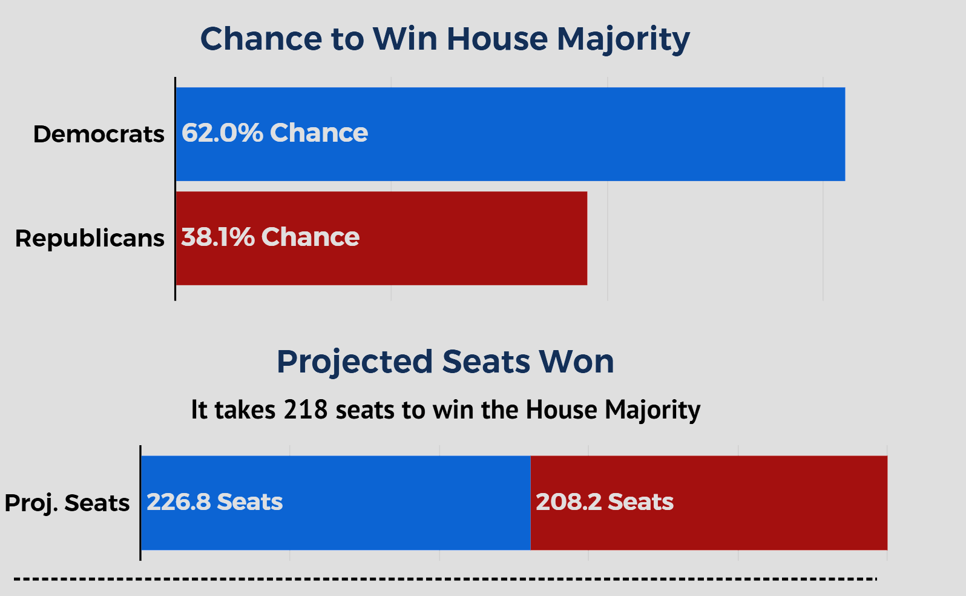
[Some Charts& Maps Omitted]
Tips for Navigating the Map
1. Zoom: To zoom in on the map on a PC, double-click on the map, then use the arrows and the +/- keys to navigate. On the phone, pinch your fingers to zoom in and out, and swipe to move around.
2. The Ruby Red Map: House Election maps will always have more red than blue - and that's because the GOP dominates in the nation's biggest sparsely populated rural districts, while Democrats dominate the tiny densely populated urban districts in big cities.
Interactive Trend Line
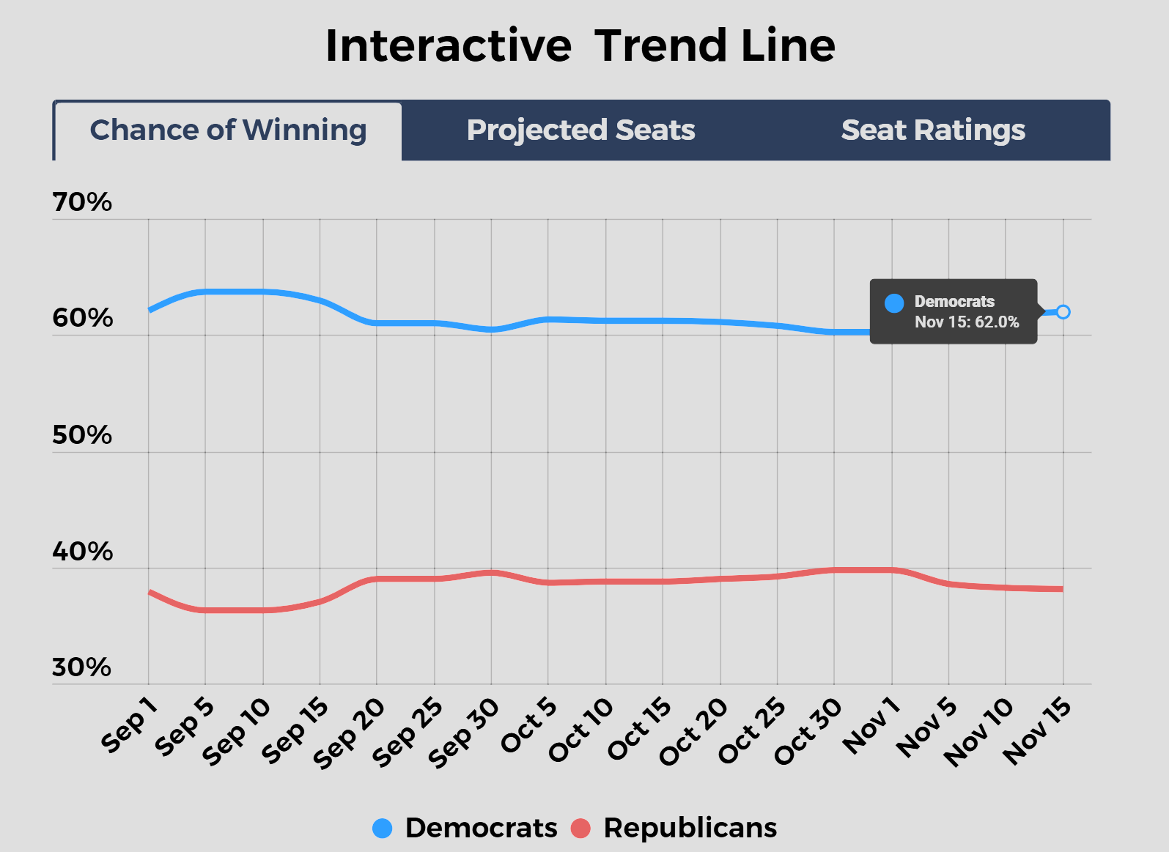

Special elections prove
Stephen Fowler, 9/26/2025, reporter for NPR, NPR, https://www.npr.org/2025/09/25/nx-s1-5548589/ken-martin-democrats-special-election-overperformance accessed 9/26/25

In the special election runoff Tuesday, Sep. 23, Democrats did not flip the deep-red seat. But Martin and others in the party view it as a win because the Democratic candidate, Debra Shigley, improved the party's margin by double digits from November.
For their part, Republicans aren't concerned. Georgia Republican Party Chairman Josh McKoon said in a statement that Republicans "cut through the noise" with a coordinated investment in digital and social media messages to get out the vote.
Still, in an interview with NPR before this week's elections, Martin said the Democratic Party is energized and voters are expressing enthusiasm after the party's defeat in November that saw them lose the White House and control of the Senate.
That enthusiasm has carried over to the ballot box: in about 40 special elections since President Trump was elected last November, Democrats have overperformed their prior margins by an average of about 15%.
Martin said some of that bump is because of Trump, and voters seeing a difference between his campaign promises and his governing. He points to polling that shows Republicans losing ground

L: OV

Plan Flips the midterms—too many reasons.

1. Anger—Unions feel lied to and betrayed after republicans ran on working class politics

2. Organization—Unions in particular are organized and vengeful, good at getting people together to take a stand

3. Unification—pain is felt across all union workers now means their unity helps that’s greenhouse

Delivering on Pro-Labor policies locks in working-class support for Republicans, flipping the midterm.
Press 25 (Eyal Press, Writer at The New Yorker; author of Dirty Work; recipient of 2022 Hillman Prize for Book Journalism; Ph.D. in Sociology from NYU; Puffin Foundation Fellow at Type Media Center; 2025; "Josh Hawley and the Republican Effort to Love Labor"; The New Yorker; doα: 11‑13‑2025)
https://www.newyorker.com/news/the-lede/josh-hawley-and-the-republican-effort-to-love-labor

But even those who question Hawley’s motives don’t doubt his ambition, particularly as jockeying for 2028 begins. One thing he appears to recognize is that siding with unions has become popular even on the right. In March, American Compass, a conservative think tank, and YouGov conducted a survey that illustrated this fact. Among Republican respondents, the poll found that labor unions had a net favorability of eight percentage points. Among young Republicans, defined as those born after 1980, the margin was thirty-eight points. Young Republicans also overwhelmingly backed several provisions of the PRO Act that the survey tested, such as expediting the collective-bargaining process, posting information about labor rights in workplaces, and penalizing companies that violate the law.
Daniel Kishi, a policy adviser at American Compass and a former aide to Hawley, told me that the generational divide captured by the survey is mirrored among Republican elected officials, with those who entered office after the 2008 financial crisis—such as Hawley and Vance—more likely to view unfettered markets skeptically and to see rank-and-file union members as potential supporters. These officials understand that, while voters in union households still tend to back Democrats, the gap has narrowed, a dynamic that has enabled Trump to win

2AC7: AFF will be marketed as a “Trump win”.

2AC4: farm vote not UQ key

BUT voters have changed their mind about undocumented immigrants.
Quinnipiac University Poll, 6—26 [The Quinnipiac University Poll, directed by Doug Schwartz Ph.D.; “Support Rises For Giving Most Undocumented Immigrants A Pathway To Legal Status vs. Deportations, Quinnipiac University National Poll Finds; More Than 9 In 10 Voters Say Politically Motivated Violence In The U.S. Is A Serious Problem,” Quinnipiac University Poll, published June 26th 2025, https://poll.qu.edu/poll-release?releaseid=3926, accessed November 15th 2025]

Nearly two-thirds of voters (64 percent) say they prefer giving most undocumented immigrants in the United States a pathway to legal status, while 31 percent say they prefer deporting most undocumented immigrants in the United States, according to a Quinnipiac (KWIN-uh-pea-ack) University national poll of registered voters released today. This is a change from roughly six months ago. In Quinnipiac University's December 18, 2024 poll, 55 percent of voters said they preferred giving most undocumented immigrants a pathway to legal status and 36 percent said they preferred deporting most undocumented immigrants in the United States. In today's poll, 31 percent of Republicans say they prefer giving most undocumented immigrants in the U.S. a pathway to legal status, while 61 percent say they prefer deporting them. Among Democrats, 89 percent say they prefer giving most undocumented immigrants in the U.S. a pathway to legal status, while 8 percent say they prefer deporting them. Among independents, 71 percent say they prefer giving most undocumented immigrants in the U.S. a pathway to legal status, while 24 percent say they prefer deporting them. ICE Voters 56 - 39 percent disapprove of the way U.S. Immigration and Customs Enforcement, known as ICE, is doing its job.

2AC3: Specifically labor protections are popular.
Sebastian, ‘23 [Kyle Ann Sebastian, Media Manager at Union of Concerned Scientists; “Voters in Key Farm Bill States Support New Approaches to the Food and Farm Bill,” Union of Concerned Scientists, published July 17th 2023, https://www.ucs.org/about/news/voters-support-new-approach-farm-bill, accessed November 15th 2025]

As Congress negotiates the 2023 Food and Farm Bill, voters across the political spectrum nationally and in four agricultural states—Colorado, Georgia, Michigan and Pennsylvania—support policies that would buffer farms from the effects of climate change and provide better workplace protections for food and farmworkers, among other issues. That’s according to new national and state polls of registered voters conducted by RABA Research. Lawmakers on the Senate and House agriculture committees responsible for crafting the Food and Farm Bill—including Senators Michael Bennet (D-Colo.), John Fetterman (D-Pa.), Debbie Stabenow (D-Mich.) and Raphael Warnock (D-Ga.) and Representatives Sanford Bishop (D-Ga.), Yadira Caraveo (D-Colo.), Austin Scott (R-Ga.), David Scott (D-Ga.), Elissa Slotkin (D-Mich.), and Glenn “GT” Thompson (R-Pa.)—should heed the results of the poll, according to the Union of Concerned Scientists, which commissioned it. “With the climate crisis driving dangerous weather across the country this summer, it’s no wonder voters see the need for Congress to act,” said Karen Perry Stillerman, deputy director of the Food and Environment Program at UCS. “People also see clearly how big corporations have hijacked our food system, endangering workers, squeezing small and midsize farmers, and leaving too many hungry, and they want a new Food and Farm Bill that works for all of us.” In a poll of voters across the country, voters expressed strong support for programs that help farmers adapt to and protect against losses due to extreme weather and for greater workplace protections in farming and food industries. Further surveys of voters in four key agriculture states found: Almost 70% of registered voters in Colorado, Georgia, Michigan and Pennsylvania—and 82% of voters in those states with a farmer in the house—identified crop failures from extreme weather as a threat to their state. Overwhelming majorities, 82% of voters nationally and as high as 90% in Michigan, supported investing in programs that help farmers proactively adapt and protect their land and crops against losses from flooding and drought. One such federal program, the Conservation Stewardship Program (CSP), is highly effective and popular with farmers, but chronically underfunded. The Inflation Reduction Act made key climate-focused investments in CSP and similar programs that must be maintained in the Food and Farm Bill. Voters in the four states are highly motivated in their support for programs that would help farmers adapt to extreme weather and mitigate climate change. Majorities in Colorado (69%), Georgia (66%), Michigan (65%) and Pennsylvania (70%) said they would be more likely to support a candidate for office who offered ideas along those lines. Large majorities in each of the four states, upwards of 76% of voters, identified corporate consolidation that squeezes small and midsize farmers and food businesses as a threat in their state. Notably, that jumped to 89% of households with a farmer. Majorities in every state, with a high of 89% in Pennsylvania, supported increasing investments that help small and midsize farmers compete with large corporate agribusiness. Majorities of voters in the four states – as many as 64% in Georgia and 70% of voters with a farmer in the house across states – said the risk of illness and injury to essential food and farm industry workers is a threat to communities in their state. Overwhelming majorities in all four states – as large 87% in Michigan and Pennsylvania – and 80% nationally supported more and better workplace protections for workers in food and farming industries. Very large majorities of voters supported programs that help farmers protect water quality and keep more carbon and nutrients in their soil, from 86% in Georgia to a high of 88% in Michigan and Pennsylvania. Majorities of voters in each state – as many as 68% in Michigan – and 66% of voters with a farmer in the house said water pollution caused by agricultural runoff is a threat to their state.

2AC2: AFF is perceived as a pro-labor win—plus their ev is just about how Kirk hates immigrants, not voters.

Kirk hasn’t affected economic perceptions, which are key to the link and the election.
Grobe 25 (Stefan Grobe, Staff Reporter at Euronews; 09‑22‑2025; "Was Charlie Kirk’s funeral in Arizona a turning point for Trump?"; Euronews; doα: 11‑09‑2025) https://www.euronews.com/2025/09/22/was-kirks-funeral-an-inflexion-point-for-trump

Trump's poll numbers have tanked
And here, Trump’s approval ratings have tanked.
In the AP-NORC poll, 62% of respondents say they disapprove of the way President Trump is handling the economy (up from 53% in August), 63% are dissatisfied with his trade policy.
A Washington Post-Ipsos poll, also taken after Kirk’s death, paints a similar downbeat picture of Trump’s presidency eight months into his second term.
In this poll, respondents disapprove of the way Trump is handling tariffs (64%) and the overall economy (59%) by large margins.
And according to a Yahoo/YouGov poll from early September, 62% of respondents disapprove of the way Trump is handling inflation and cost of living.
These numbers on the economy could be especially concerning for Republicans ahead of the midterms. More than two-thirds of Americans describe the state of the economy as “poor” or “not so good”.

2AC5+6: Lobby Backlash—their ev doesn’t say anywhere that this backlash will be enough to convince voters to turn against republicans in the midterms—all our perception ev has yet to be indicted.

Working-class issues are a top priority.
Bolden 25 (Leslie Bolden; 08‑13‑2025; "Done With The Democrats: Working-Class Voters Feel Abandoned By The Party"; AOL (Originally Tampa Free Press); doα: 11‑09‑2025)
https://www.aol.com/news/done-democrats-working-class-voters-223420894.html

In a deeply revealing report from the New York Times, a growing sentiment of disillusionment is emerging from a key demographic that once formed the bedrock of the Democratic Party: working-class Americans. Many of these voters, who cast their ballots for former President Joe Biden in 2020, now say they feel left behind and are skeptical the party can ever regain their trust.
The report highlights a significant shift, with several interviewees expressing regret over their 2020 vote and explaining their pivot to supporting President Donald Trump in 2024. Desmond Smith, a Black man who backed Biden, told the NYT, “I think I’m done with the Democrats.”
He articulated a common frustration, stating that to win him back, Democrats must “fight for Americans instead of fighting for everybody else.”
This sentiment was echoed by others who feel the party has lost touch with their daily struggles. Kendall Wood, a truck driver from Virginia, explained his switch from Biden to Trump, noting that Democrats "seemed like they were more concerned with [DEI] and LGBTQ issues and really just things that didn’t pertain to me or concern me at all.” He added, "They weren’t concerned with, really, kitchen-table issues.”
Maya Garcia, a restaurant server from California who voted for Biden in 2020 but sat out the 2024 election, expressed a similar financial anxiety. She told the NYT that while Democrats "talk a lot about us emotionally," they fail to provide a clear plan for economic stability. "What are we going to do financially?" she asked, adding, “I understand that you want, you know, equal rights and things like that. But I feel like we need to talk more about the economics.”
The NYT report also touches on the complex political landscape for those who supported Trump's "America First" platform. Kyle Bielski of Arizona, who connected with this message in 2024, admitted he feels the president is not fully delivering on those promises. “We’re getting into more stuff abroad and not really focusing on economics here,” he said, questioning if the president is "holding true to anything that he’s promised."
A Democratic pollster, John Anzalone, candidly told the NYT that the party's biggest problem is its lack of an economic message. “They think that this is about Trump’s numbers getting worse,” he said, "They need to worry about their numbers.” This stark warning comes as some Democrats are urging the party to move away from left-wing messaging and reclaim a more center-left identity.
The stakes are high for Democrats as they look toward the upcoming midterms and the 2028 presidential election. As DNC Chairman Ken Martin stated earlier this year, many Americans now view the GOP as the "party of the working class," while the Democrats are seen as the "party of the elites." The NYT report suggests this perception is not only real but is a deeply rooted problem that could define the political battles of the next decade. Sources

L: UQ of L

Link shapes. Only a risk the plan is worse. It was dropped.

The plan flips the midterm and cements a long-term realignment that turns working class voters into a core Republican constituency:

The aff is a huge win. Ag workers rights reshapes the American economy and is a hand out to union bosses that drive political engagement and donate to campaigns.

Working class voters are turning against Trump now.
Glueck 25 (Katie Glueck, National political reporter at The New York Times; previously Chief Metro political correspondent; 08‑16‑2025; "These Are the Voters Who Should Scare Democrats Most"; The New York Times; doα: 11‑10‑2025) https://www.nytimes.com/2025/08/12/us/politics/democrats-working-class-voters.html

Working-class voters like Mr. Teachey, who supported Joseph R. Biden Jr. in 2020 but either backed President Trump last year or, as Mr. Teachey did, skipped the 2024 presidential election, help explain why Democrats lost pivotal swing counties like Bucks, and vividly illustrate how the traditional Democratic coalition has eroded in the Trump era.
Now, Democrats hope to bring these voters back into the fold for the midterm elections in 2026, betting on a backlash to Mr. Trump and his party’s far-reaching moves to slash the social safety net.
But in interviews with nearly 30 predominantly working-class voters who supported Mr. Biden in 2020 before defecting or struggling deeply with their choices last year, many had a stinging message for the Democratic Party.
Just because we have misgivings about Mr. Trump, they say, it doesn’t mean we like you.
“I think I’m done with the Democrats,” said Desmond Smith, 24, a deli worker from Smithdale, Miss., and a Black man who said he backed Mr. Biden in 2020 at the height of the racial justice protests. But last year, disillusioned by what he saw as the party’s overemphasis on identity politics and concerned about illegal immigration, he voted for Mr. Trump.
Asked how Democrats could win him back, he said, “Fight for Americans instead of fighting for everybody else.”
An in-depth post-election study from Pew Research Center suggests that about 5 percent of Mr. Biden’s voters in 2020 switched to Mr. Trump in 2024, while roughly 15 percent of those voters stayed home last year. Mr. Trump retained more of his 2020 voters than Democrats did, a crucial factor in winning the election.
Polling on the current attitudes of those Biden defectors is limited, but it is clear the Democratic brand, broadly, continues to struggle. A Wall Street Journal poll released in late July found that the party’s image was at its lowest point in more than three decades, with just 33 percent of voters saying they held a favorable view of Democrats.
“They’re doing nothing to move their own numbers because they don’t have an economic message,” said John Anzalone, a veteran Democratic pollster who worked on that survey.
“They think that this is about Trump’s numbers getting worse,” he added. “They need to worry about their numbers.”
Certainly, anger with Mr. Trump, an energized Democratic base and the headwinds a president’s party typically confronts in midterm elections could help propel Democrats to victory next year.

NB: A2 “Links 2 States”

Wrong—republicans aren’t in charge of all states now—just an assertion, no evidence. States doing it not the same as Trump doing it—perception of Trump is key to midterms.

M: Solves Case

Squo solves. A dem wave guarantees the plan, along with additional labor protections
Bobic & Jamieson 25, *senior HuffPost reporter, **HuffPost labor reporter. (*Igor and **Dave, March 5, 2025, “Democrats Reintroduce Sweeping Bill To Strengthen Unions,” HuffPost, https://bobbyscott.house.gov/media-center/in-the-news/democrats-reintroduce-sweeping-bill-strengthen-unions,)

WASHINGTON – Congressional Democrats on Wednesday reintroduced the Protecting the Right to Organize Act, or PRO Act, a sweeping bill aimed at boosting union membership after decades of decline.
The legislation, led this year by Sen. Bernie Sanders (I-Vt.) and Rep. Bobby Scott (D-Va.), would amount to the most significant overhaul to labor law in nearly 80 years, making it easier for workers to organize and bargain union contracts and more costly for employers to violate their rights.
“For too long, workers have suffered from anti-union attacks and toothless labor laws that have undermined their right to work safely and be paid fairly,” Scott said at a press conference at the U.S. Capitol on Wednesday.
“In the last few weeks, we have seen Elon Musk, the wealthiest man on earth, single-handedly terminate the jobs of hundreds of thousands of federal employees,” Sanders added. “If Musk and his friends can arbitrarily fire hundreds of thousands of federal employees, what to you think they’ll do to the millions of workers who are impacted by technological revolution and artificial robotics?”
“The only protection that workers will have from massive layoffs,” the senator added, “is through forming unions, standing up for their rights, and making sure the new technology benefits workers and not just the oligarchs.”
The legislation was first introduced in Congress in 2019 with the support of a broad range of labor unions, progressive groups and worker advocates. But not every Democratic lawmaker was on board at the time, especially in the Senate, where a handful of members of the Democratic caucus had expressed concerns for businesses and independent contractors.
Now, with conservative Democrat Joe Manchin and independent Kyrsten Sinema retired and out of the Senate, support within the Democratic Party for the legislation is expected to be unanimous, a mark of progress for the labor movement despite the fact that Republicans control both chambers of Congress and aren’t likely to take it up.

M: Turns Case

A republican congress turns case.
Driskell 25, adjunct professor of legislative politics, where he teaches courses on race, religion, and politics at the George Washington University Graduate School of Political Management (Quardricos, “If Democrats Don’t Take Back the House in 2026, America Should Be Alarmed,” The Christian Recorder, https://www.thechristianrecorder.com/articles/if-democrats-dont-take-back-the-house-in-2026-america-should-be-alarmed/)

As we approach the 2026 midterm elections and the start of the 119th Congress, Americans must confront a sobering reality: if Democrats fail to regain control of the House of Representatives, our democracy may face further erosion at the hands of extremism, gridlock, and a deepening assault on institutional norms. The stakes could not be higher.
Since reclaiming the House in 2022, Republicans have increasingly used their majority not to govern but to obstruct. Committee rooms have become arenas for political theater. Subpoenas are issued not in the pursuit of oversight but in the name of vengeance. Critical legislation—from reproductive rights and voting access to climate action and gun reform—has been held hostage by a far-right faction whose allegiance is not to the Constitution, but to conspiracy and power.
If this continues into the 119th Congress, the consequences will be dire.
First, a Republican-controlled House in 2026 would likely intensify efforts to delegitimize federal agencies, undermine the rule of law, and weaponize congressional investigations to damage political opponents. In recent sessions, we’ve already witnessed sham impeachments, threats to defund the Federal Bureau of Investigation (FBI) and Department of Justice (DOJ), and coordinated attacks on public health institutions. Expect more of the same—if not worse—if another majority emboldens Speaker Johnson and President Trump.
Second, the ability to pass essential legislation will grind to a halt. The country faces urgent challenges: a warming planet, deepening inequality, an aging infrastructure, and a fragile healthcare system. But if Democrats do not regain control of the House, we can expect more manufactured shutdowns, debt ceiling brinkmanship, and resistance to common-sense solutions.
Third—and perhaps most ominously—a Republican House will continue its march toward authoritarianism. The 2026 midterms are not just about partisan advantage; they are about preserving democratic norms and rejecting a movement that has openly questioned the validity of elections, embraced political violence, and trafficked in white Christian nationalism. A Democratic House is the firewall we need to protect voting rights, defend judicial independence, and ensure a peaceful power transfer in 2028.
This is not about blind allegiance to any political party—I am not a Democrat. Rather, it is about supporting those prepared to govern with integrity, speak the truth, and uphold the ideals of a pluralistic democracy.
If Democrats fail to reclaim the House in 2026, the consequences could be profound. Vital reforms will stall, and the legislative branch may continue to descend into dysfunction. Those who thrive on chaos and exploit it for political gain will further erode the credibility and effectiveness of our government.
Let us be clear-eyed: the future of the Republic does not hinge on one election alone. But the 2026 midterms may determine whether we choose governance or grievance, democracy or demagoguery.
The House must be reclaimed—not simply for partisan advantage, but for preserving the American republic itself.

